Key people – RE and STEAM – 2026/27
 | RE | Science | Technology | Engineering | Artist | Mathematician
EYFS | Saint Teresa (Mother Theresa) of Calcutta – Dedicated herself to helping the poor and is considered one of the 20th Century's greatest humanitarians  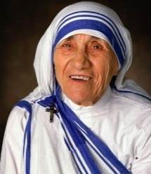 | Mae Jamison - an engineer, physician, and former NASA astronaut. She became the first black woman to travel into space when she served as a mission specialist aboard the Space Shuttle Endeavour.  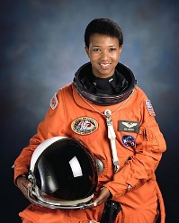 | Wallace and Gromit - eccentric inventor and his trusted canine friend   | Annette Ashberry - a British engineer, gardener and author, and the first woman elected to the Society of Engineers.  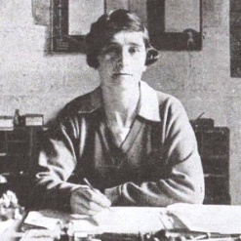 | Andy Warhol – American pop artist  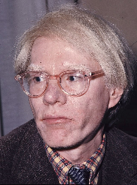 | Johanna Lucht – NASA engineer who is deaf  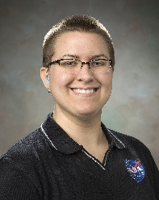
Y1 | Saint Monica of  Hippo - Saint Monica was known for her patience, gentleness and prayers  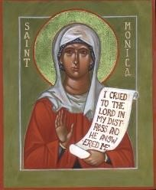 | Sir David Attenborough - British broadcaster, biologist, natural historian, and writer.  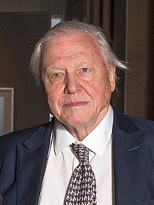 | Ole Kirk Christiansen – Founder of lego  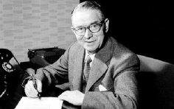 | Isambard  Kingdom Brunel –  Railways and  Bristol Suspension  Bridge  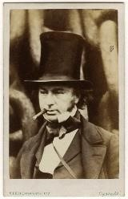 | Michele Curtis – Seven Saints of St Pauls murals  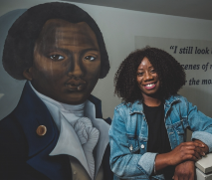 | Malala Yousafzai - Pakistani female education activist and the 2014 Nobel Peace Prize laureate at the age of 17.  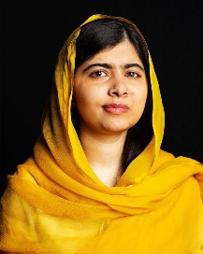
Y2 | St Martin de Porres - Kind and caring saint, cared for all people and animals  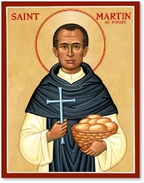 | Charlotte Armah - Nutritional Biochemist  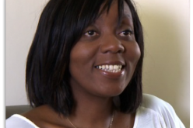 | Frank Whittle - Flight technologist who co-created the turbojet engine.  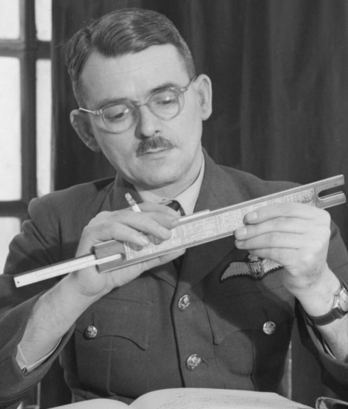 | Lanny Smoot – Disney engineer  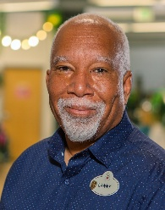 | Yayoi Kusama - A Japanese contemporary artist  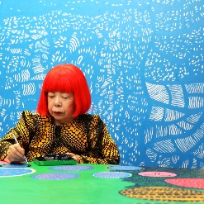 | Katherine Johnson - One of the first African American women to work at NASA  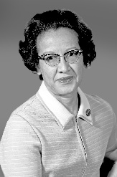
Y3/4  AND  Y4/5 | Saint Josephine Bakhita - When she was 8 years old she was sold in a slave market  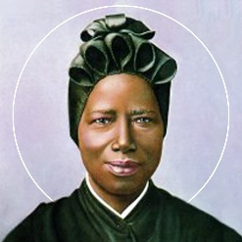 | Maggie Aderin-Pocock – Space scientist and science educator. She is also dyslexic.  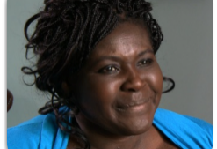 | Timothy Berners Lee - Engineer of the World Wide Web  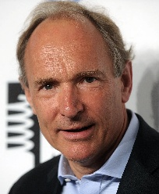 | Aprille Ericsson-Jackson - Aerospace Engineer  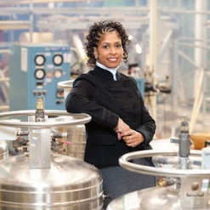 | Claes Oldenburg - Swedish-born American sculptor best known for his public art installations, typically featuring large replicas of everyday objects.  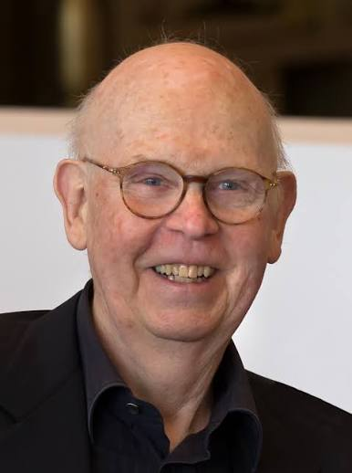 | John Nash -Greatest mathematical thinker of the 20th century  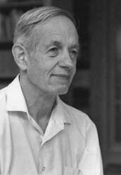
Y6 | St Wulstan – Local Saint who fought the slave trade in Bristol in the 11th Century, before we even think the slave trade was happening! He also built a college in Westbury-on-Trym, the ruins of which are still around today  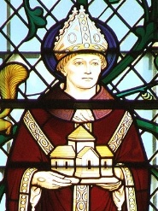 | Greta Thunberg – Climate activist   | Garrett A. Morgan – Inventor of the first gas mask  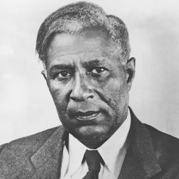 | Alan Turing - Turing was highly influential in the development of theoretical computer science  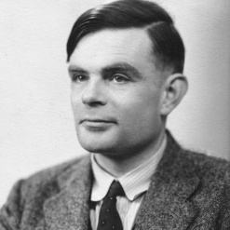 | Kara Walker -American artist perhaps best known for paper silhouettes that she uses to address issues of racism and sexism  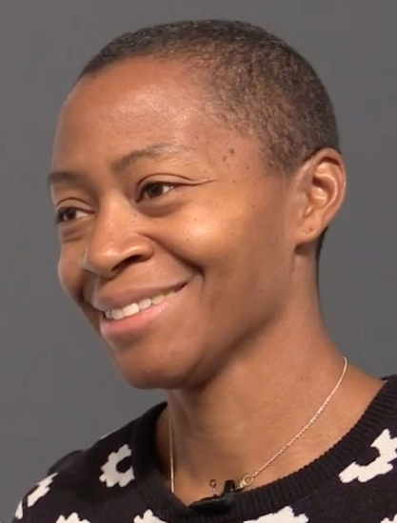 | Hannah Fry – British Mathematician – The mathematics of probability  

STEAM DAYS 26/27:
Term 1: RE: Monday 19th October – Assembly for parents and whole school at 2.30pm
Term 2: SCIENCE: Wednesday 2nd December - Assembly for parents and whole school at 2.30pm
Term 3: TECHNOLOGY: Tuesday 26th January - Assembly for parents and whole school at 2.30pm
Term 4: ENGINEERING: Wednesday 10th March - Assembly for parents and whole school at 2.30pm
Term 5: ART: Monday 26th April - Assembly for parents and whole school at 2.30pm
Term 6: MATHS: Tuesday 6th July - Assembly for parents and whole school at 2.30pm

