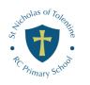
Useful contact numbers for Parents/ Carers

If you are worried about child or young person’s safety or wellbeing please contact
- First Response : 0117 949 0944- (01454 615165 at weekends and evenings.) https://bristolsafeguarding.org/
- Access and Response: (If you live in south Glos) 01454 866000 (01454 615165 at weekends and evenings.) http://sites.southglos.gov.uk/safeguarding/
- Single Point Access: (if you live in North Somerset) 01275888808 (01454 615165 at weekends and evenings.) https://www.northsomersetsafeguarding.co.uk/

- NSPCC 24 hour Helpline: 0800 800 5000 (free from a landline)
- NSPCC Text helpline: 88858 (service is free and anonymous)

- NHS 111 – NHS: NHS 111 can help if you have an urgent medical problem and you’re not sure what to do. ... go to 111.nhs.uk

- Police – 101 non-emergency calls or 999 in an emergency


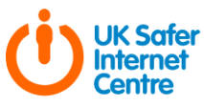
https://www.saferinternet.org.uk/ Information on Online safety for
parents and students.

The parent INFO- website provides help and information for families in the digital world (https://parentinfo.org/

Childnet- This website will provide you with all the all the information you need to keep your child safe online. This includes information on Cyberbullying, sexting, how to remove harmful content. https://www.childnet.com/parents-and-carers

Internet Matters- Access to lots of information and advice for a variety of age groups on all subjects related to online concerns-behaviour
https://www.internetmatters.org/resources/esafety-leaflets-resources/



Young Minds: Resources and emotional wellbeing tips and advice for parents. Parents’ Helpline (Mon-Fri 9:30 - 4pm) 0808 802 5544 www.youndminds.org.uk/forparents

Self Harm UK: A UK based charity that offers support. Useful facts, information, and advice to parents and young people www.selfharm.co.uk

Child Bereavement: UK Charity that supports families who have experienced the loss of a child or when a child is facing loss.
www.childbereavementuk.org

NSPCC- The NSPCC website provides a variety of information and support on topics ranging from Mental Health, drugs and alcohol awareness and sexual behaviour in children as well as many other areas of concern https://www.nspcc.org.uk/keeping-children-safe/

Kooth, is an online counselling and emotional well-being platform for children and young people, accessible through mobile, tablet and desktop and free at the point of use. https://www.kooth.com/

OTR- mental health social movement by and for young people aged 11-25 living in Bristol and South Gloucestershire https://www.otrbristol.org.uk/

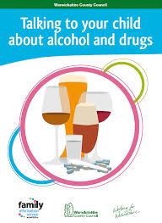

BDP-Bristol Drugs Project-Whether you're using alcohol or drugs yourself, or you're being affected by someone else's use, we can provide you with free and confidential support. https://www.bdp.org.uk/youth
Alateen: Support for families and friends of alcoholics 0207 403 0888
Confidential Helpline www.al-anonuk.org.uk/alateen

FRANK: Support, advice and information on any issues or questions relating to drugs and alcohol 24/365 Helpline 0300 123 6600 SMS 8211 www.talktofrank.com



Anti-Bullying Alliance- Information and advice about bullying for parents/carers
https://www.anti-bullyingalliance.org.uk/tools-information/advice-parents
National Bullying Helpline-advice and guidance for parents and carers
https://www.nationalbullyinghelpline.co.uk/kids.html
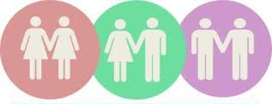

Brook Advice: Advice around sexual health and contraception www.brook.org.uk
FPA- Advice for parents and carers on how to have difficult discussions regarding relationships and sex with young people
https://www.fpa.org.uk/sites/default/files/fpa-sexual-health-week-2017-tips-for-parents.pdf
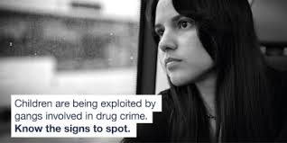

The Children’s Society- Advice and guidance can be found in several different languages on the subject of Child Criminal Exploitation including County Lines.
https://www.childrenssociety.org.uk/what-we-do/our-work/tackling-criminal-exploitation-and-county-lines/county-lines-resources
NSPCC- Advice on the signs that someone is at risk of Child sex expoitation and what you can do to support them
https://www.nspcc.org.uk/what-is-child-abuse/types-of-abuse/child-sexual-exploitation/

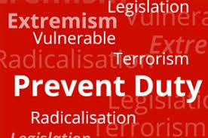

NSPCC- Advice and guidance on protecting children from radicalisation
https://www.nspcc.org.uk/keeping-children-safe/reporting-abuse/dedicated-helplines/protecting-children-from-radicalisation/
Educate against Hate- advice and guidance on how to safeguarding your child from the risks of radicalisation.
https://educateagainsthate.com/parents/
Advice for Bristol Residents.
Food bank Vouchers –If your child gets free school meals, you may be able to access food bank vouchers through the council emergency payment scheme. When you contact the emergency scheme, please explain that your family is in receipt of free school meals and rely on the school to provide a hot meal daily. You can apply online at: https://www.bristol.gov.uk/benefits-financial-help/apply-for-an-emergency-payment

Or you can contact the team by:
email: lcpf@bristol.gov.uk, include your full name and address
phone: 0117 922 4500, Monday to Friday, 9am to 12noon (we can't take household goods applications by phone)in person: Citizen Service Point, 100 Temple Street, Bristol, BS1 6AG (by appointment only). You'll need to collect emergency payments here.

Talking Money - Talking Money is an independent charity providing free, confidential advice to individuals with financial problems. There are also drop in centres in Kingswood and Staple Hill. Main Address: 1, The Hide Market, West St, Bristol BS2 0BH Phone: 0117 954 3990

Next Link –As well as domestic abuse support services we provide women's mental health support services and independent support for victims of rape and sexual abuse nextlinkhousing.co.uk
Domestic abuse telephone help lines are open 8:30am – 5:30pm Monday to Friday and 9:30am – 1:00pm on Saturday 0117 925 0680.

Local Organisations

Hillfields Church : 0117 9654140 – open all week 9.00am – 4pm
Children Centres
Hillfields Library - Phone: 0117 903 8576 Summerleaze, Bristol BS16 4HL
Speedwell childrens centre : Address: Speedwell Rd, Speedwell, Bristol BS5 7SY Phone: 0117 903 0329
Little Hayes Children Centre ; Address: Symington Rd, Bristol BS16 2LL Phone: 0117 903 0405
Kingswood Children Centre: Address: Hollow Rd, Bristol BS15 9TP Phone: 01454 864144

